## **Figures**

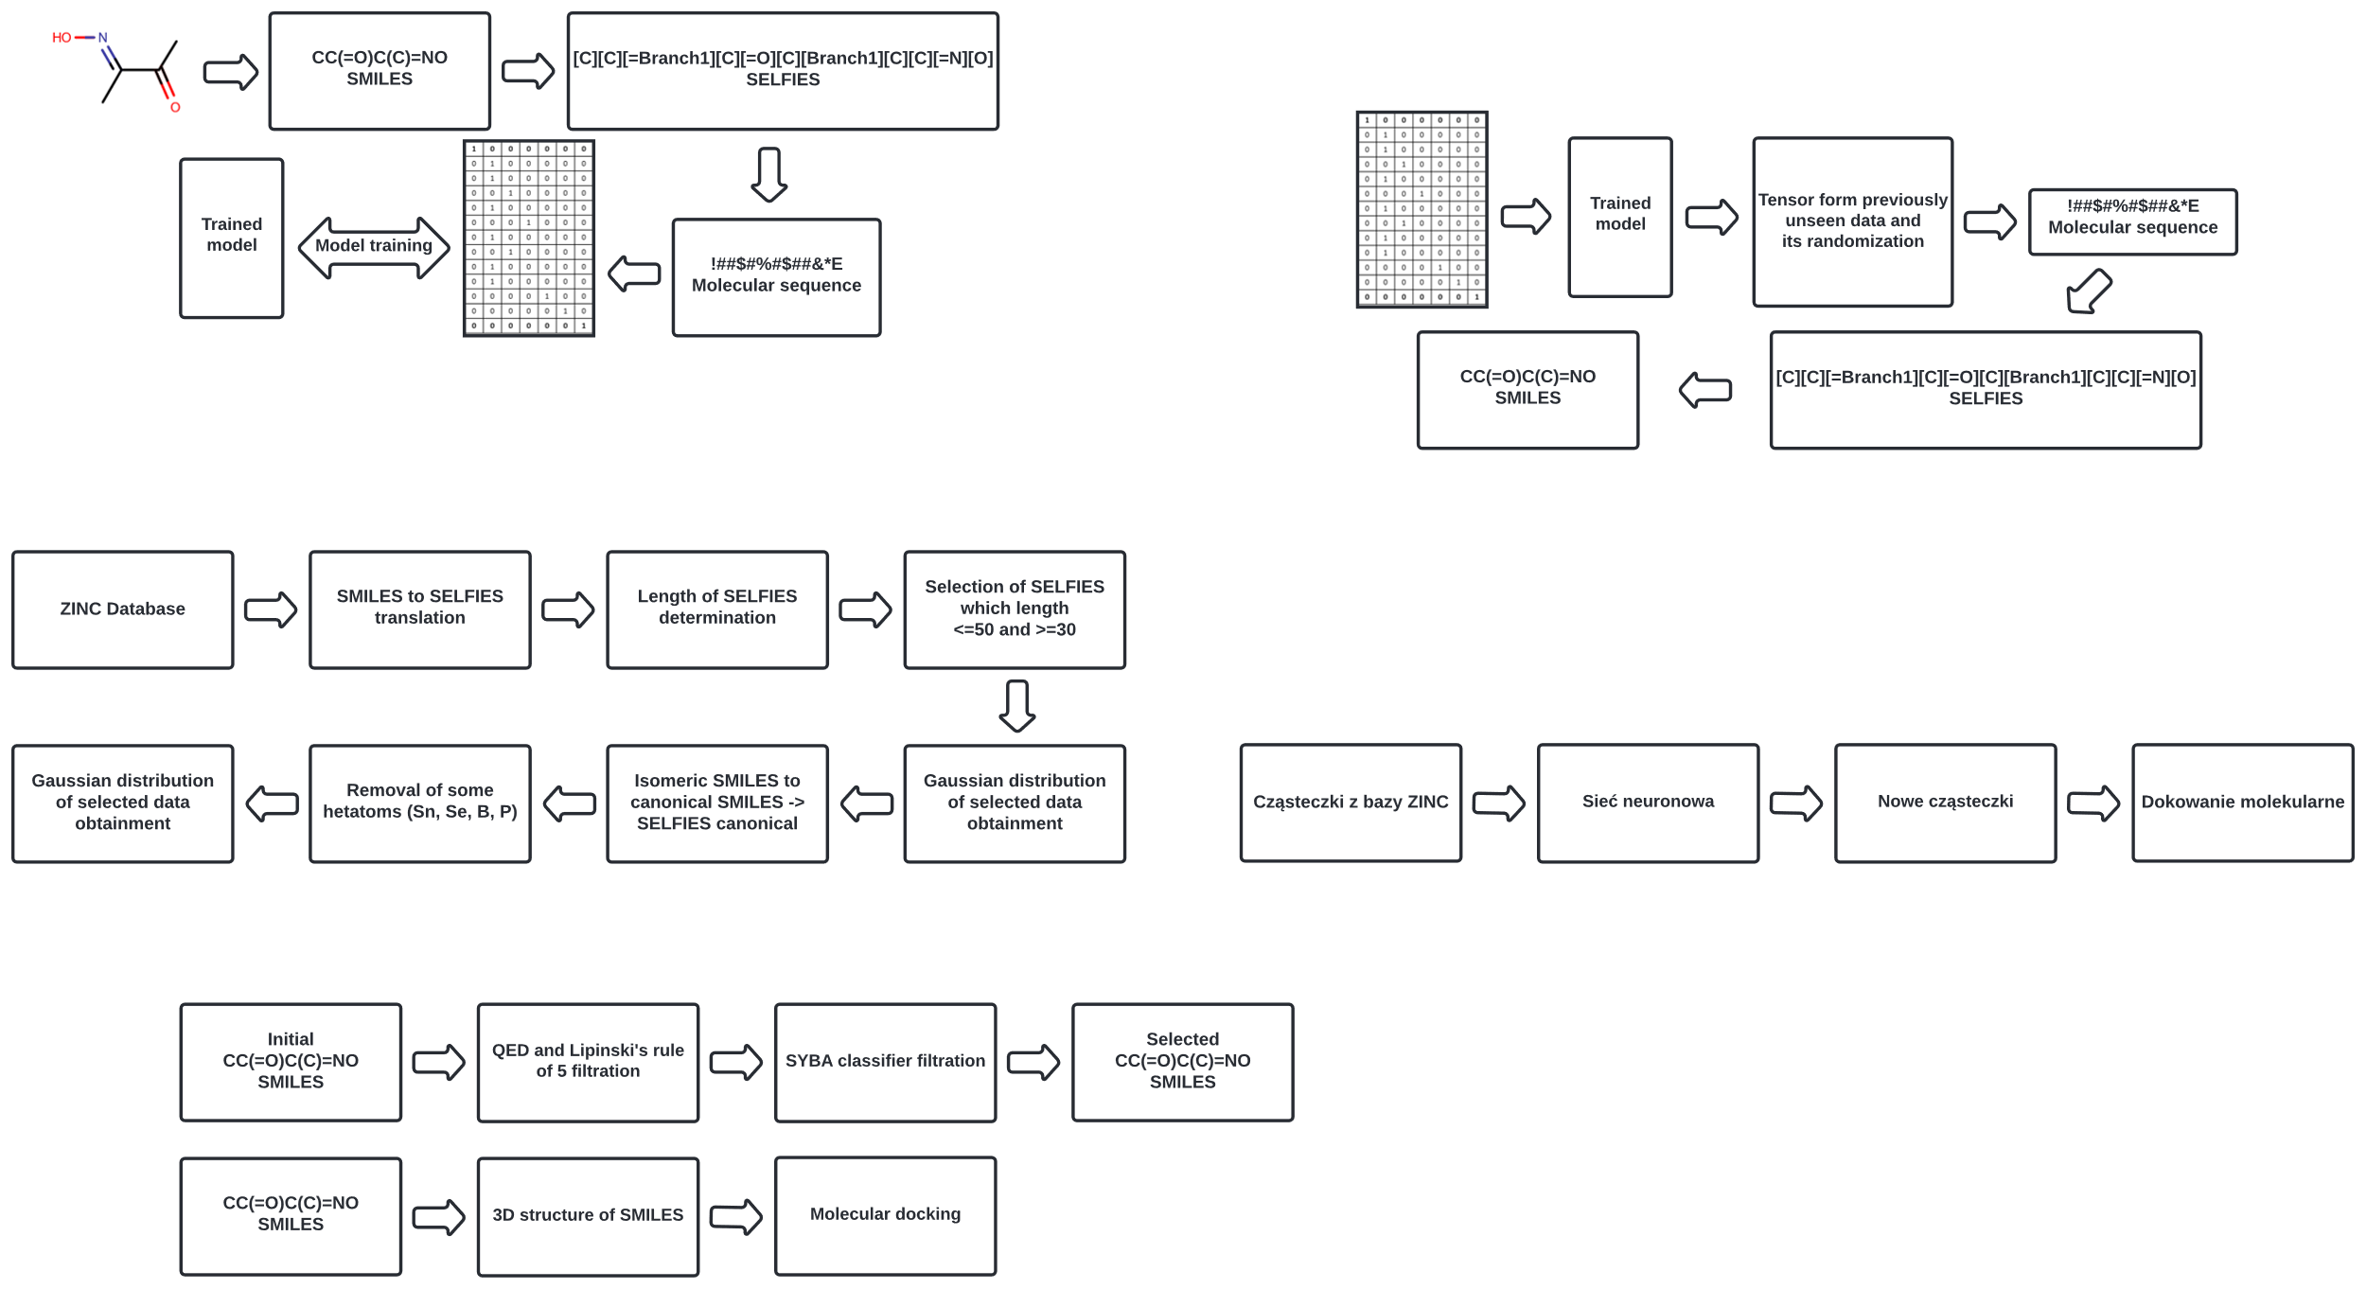

**Figure S1.** Data for model training preparation.

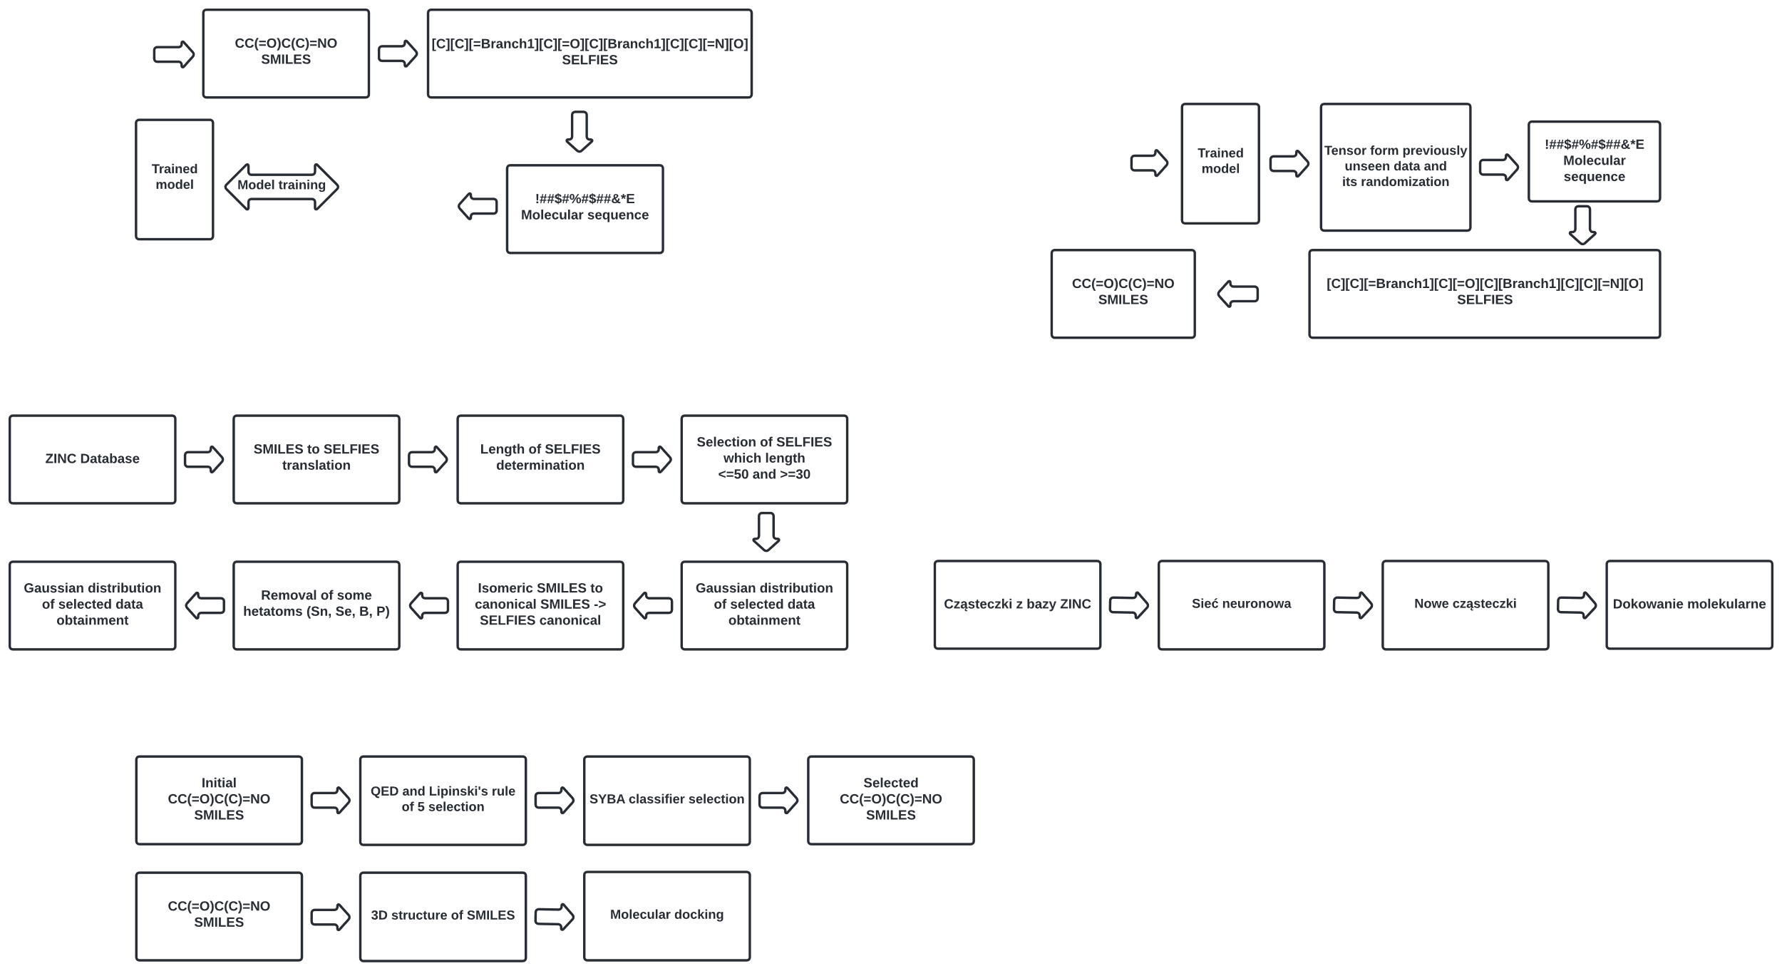

**Figure S2.** Initializer selection workflow.

**Figure S3.** The seq_to_seq model architecture.

**Figure S4.** Part of the model that encodes molecular sequences into latent space (see **File SM16**).

**Figure S5.** The latent to states model takes the tensor of a given dimension and as a result,   
states are decoded (see **File SM17**).

**Figure S6.** The sample model is used to make predictions, character by character (see **File SM18**).

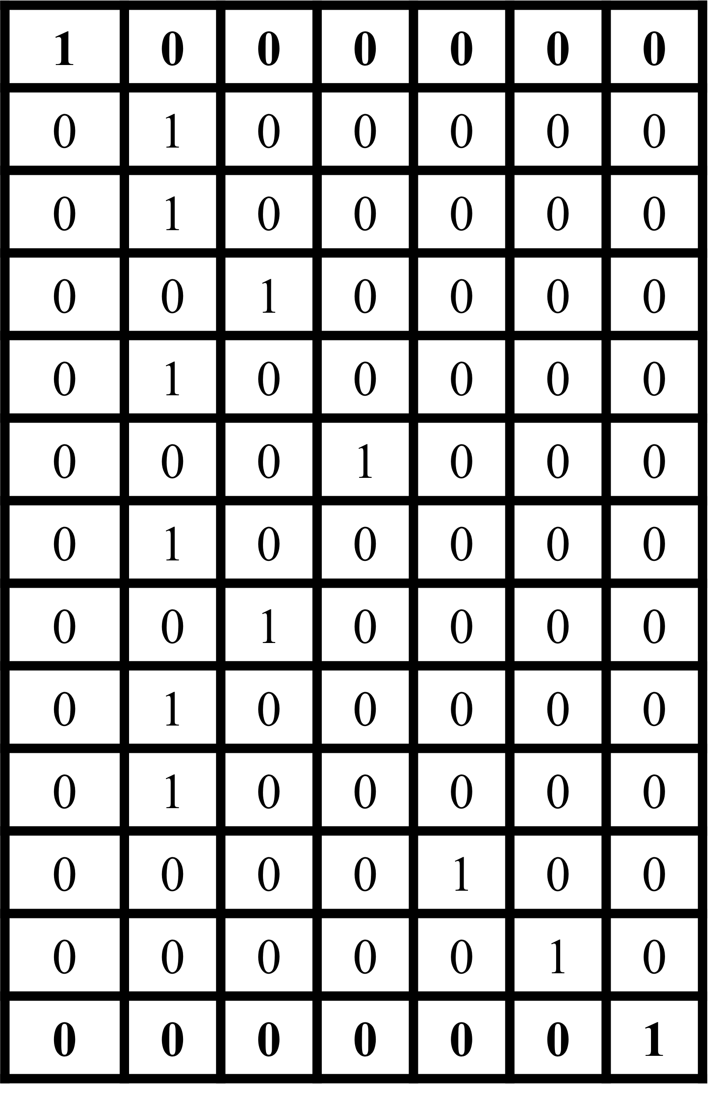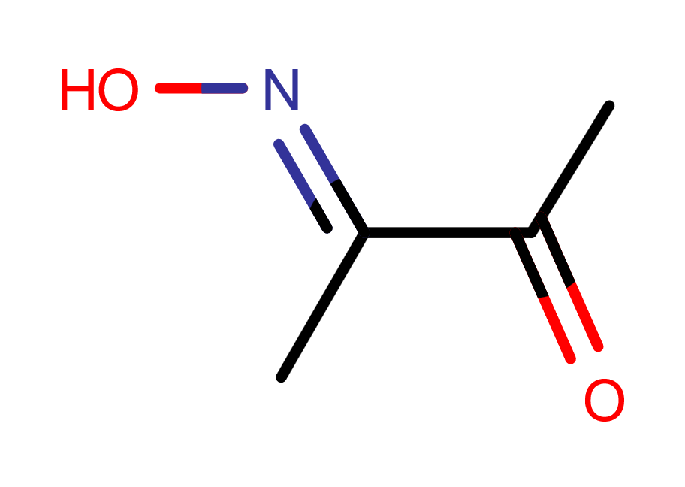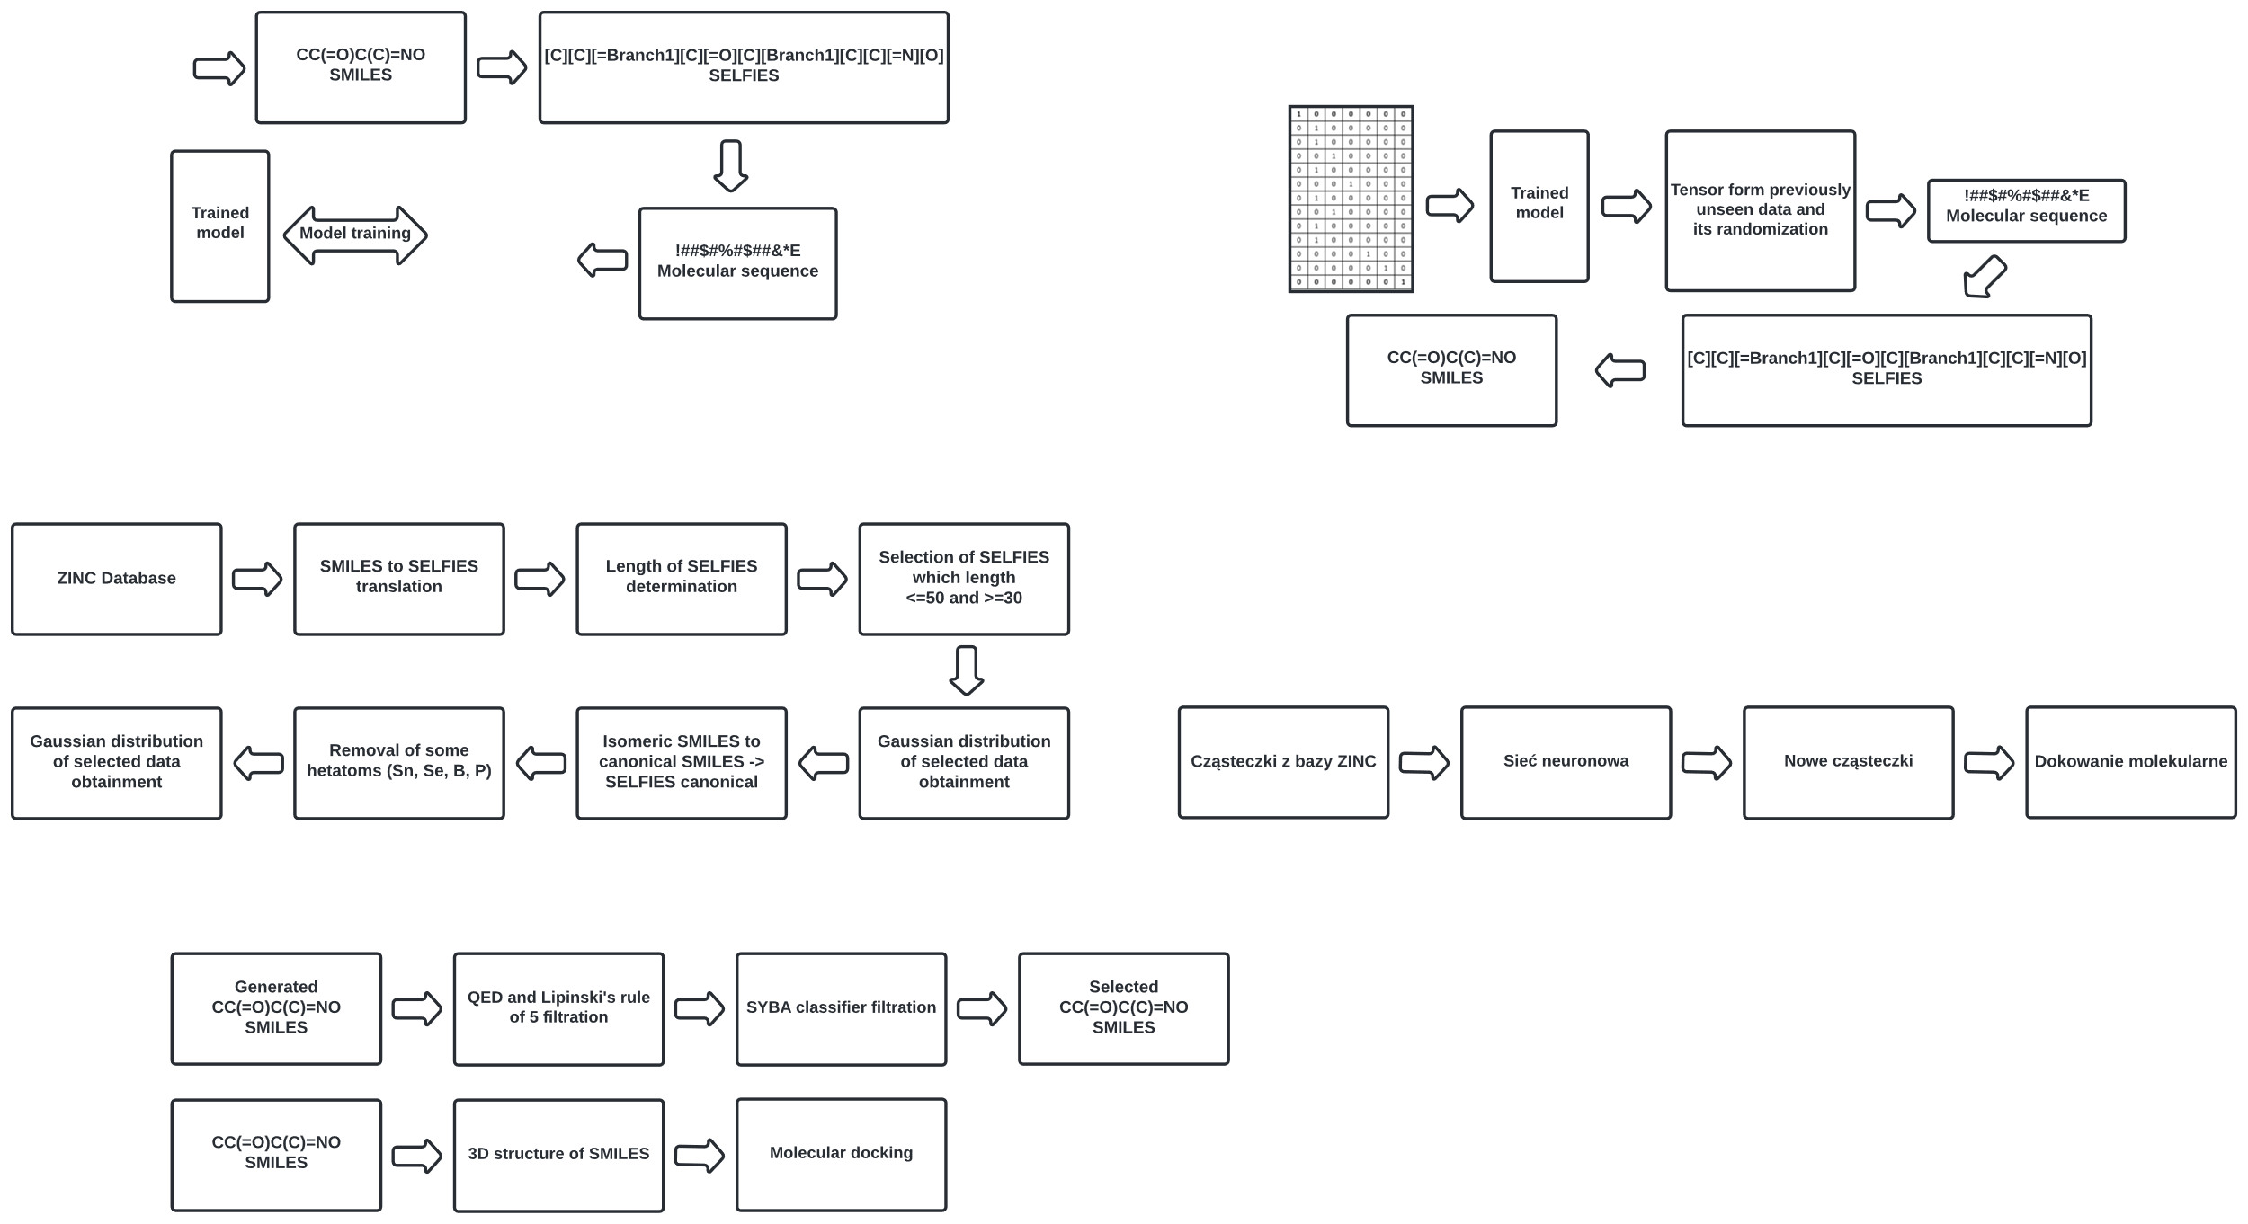

**Figure S7.** The overall training workflow.

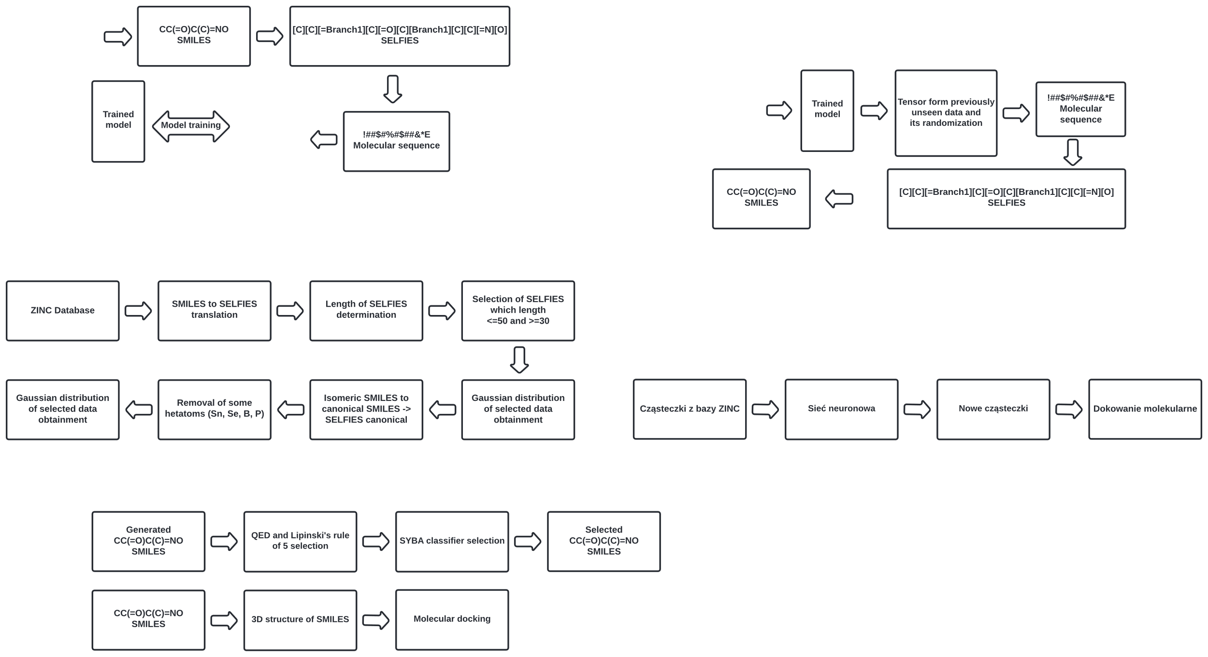

**Figure S8.** Selection of generated structures workflow.



**Figure S9.** Workflow for molecular docking.

|  |  |
| --- | --- |
|  |  |
| **Figure S10.** The QED distribution histogram for  ROR-γ active compounds with a marked threshold (red vertical line). | **Figure S11.** Histogram of Lipinski's rule of 5 fulfillment distribution for ROR-γ active compounds. |

|  |  |
| --- | --- |
|  |  |
| **Figure S12.** The SYBA score distribution histogram for ROR-γ active with a marked threshold (red vertical line). | **Figure S13.** My score distribution to 9 structures  that passed through three filters. |

|  |  |
| --- | --- |
|  |  |
| **Figure S14.** The QED distribution histogram for the first prediction with a marked threshold (red line). | **Figure S15.** Histogram of Lipinski's rule of 5 fulfillment distribution for the first prediction. |

|  |  |
| --- | --- |
|  |  |
| **Figure S16.** The QED distribution histogram  for the second prediction with a marked threshold (red vertical line). | **Figure S17.** Histogram of Lipinski's rule of 5 fulfillment distribution for the second prediction. |

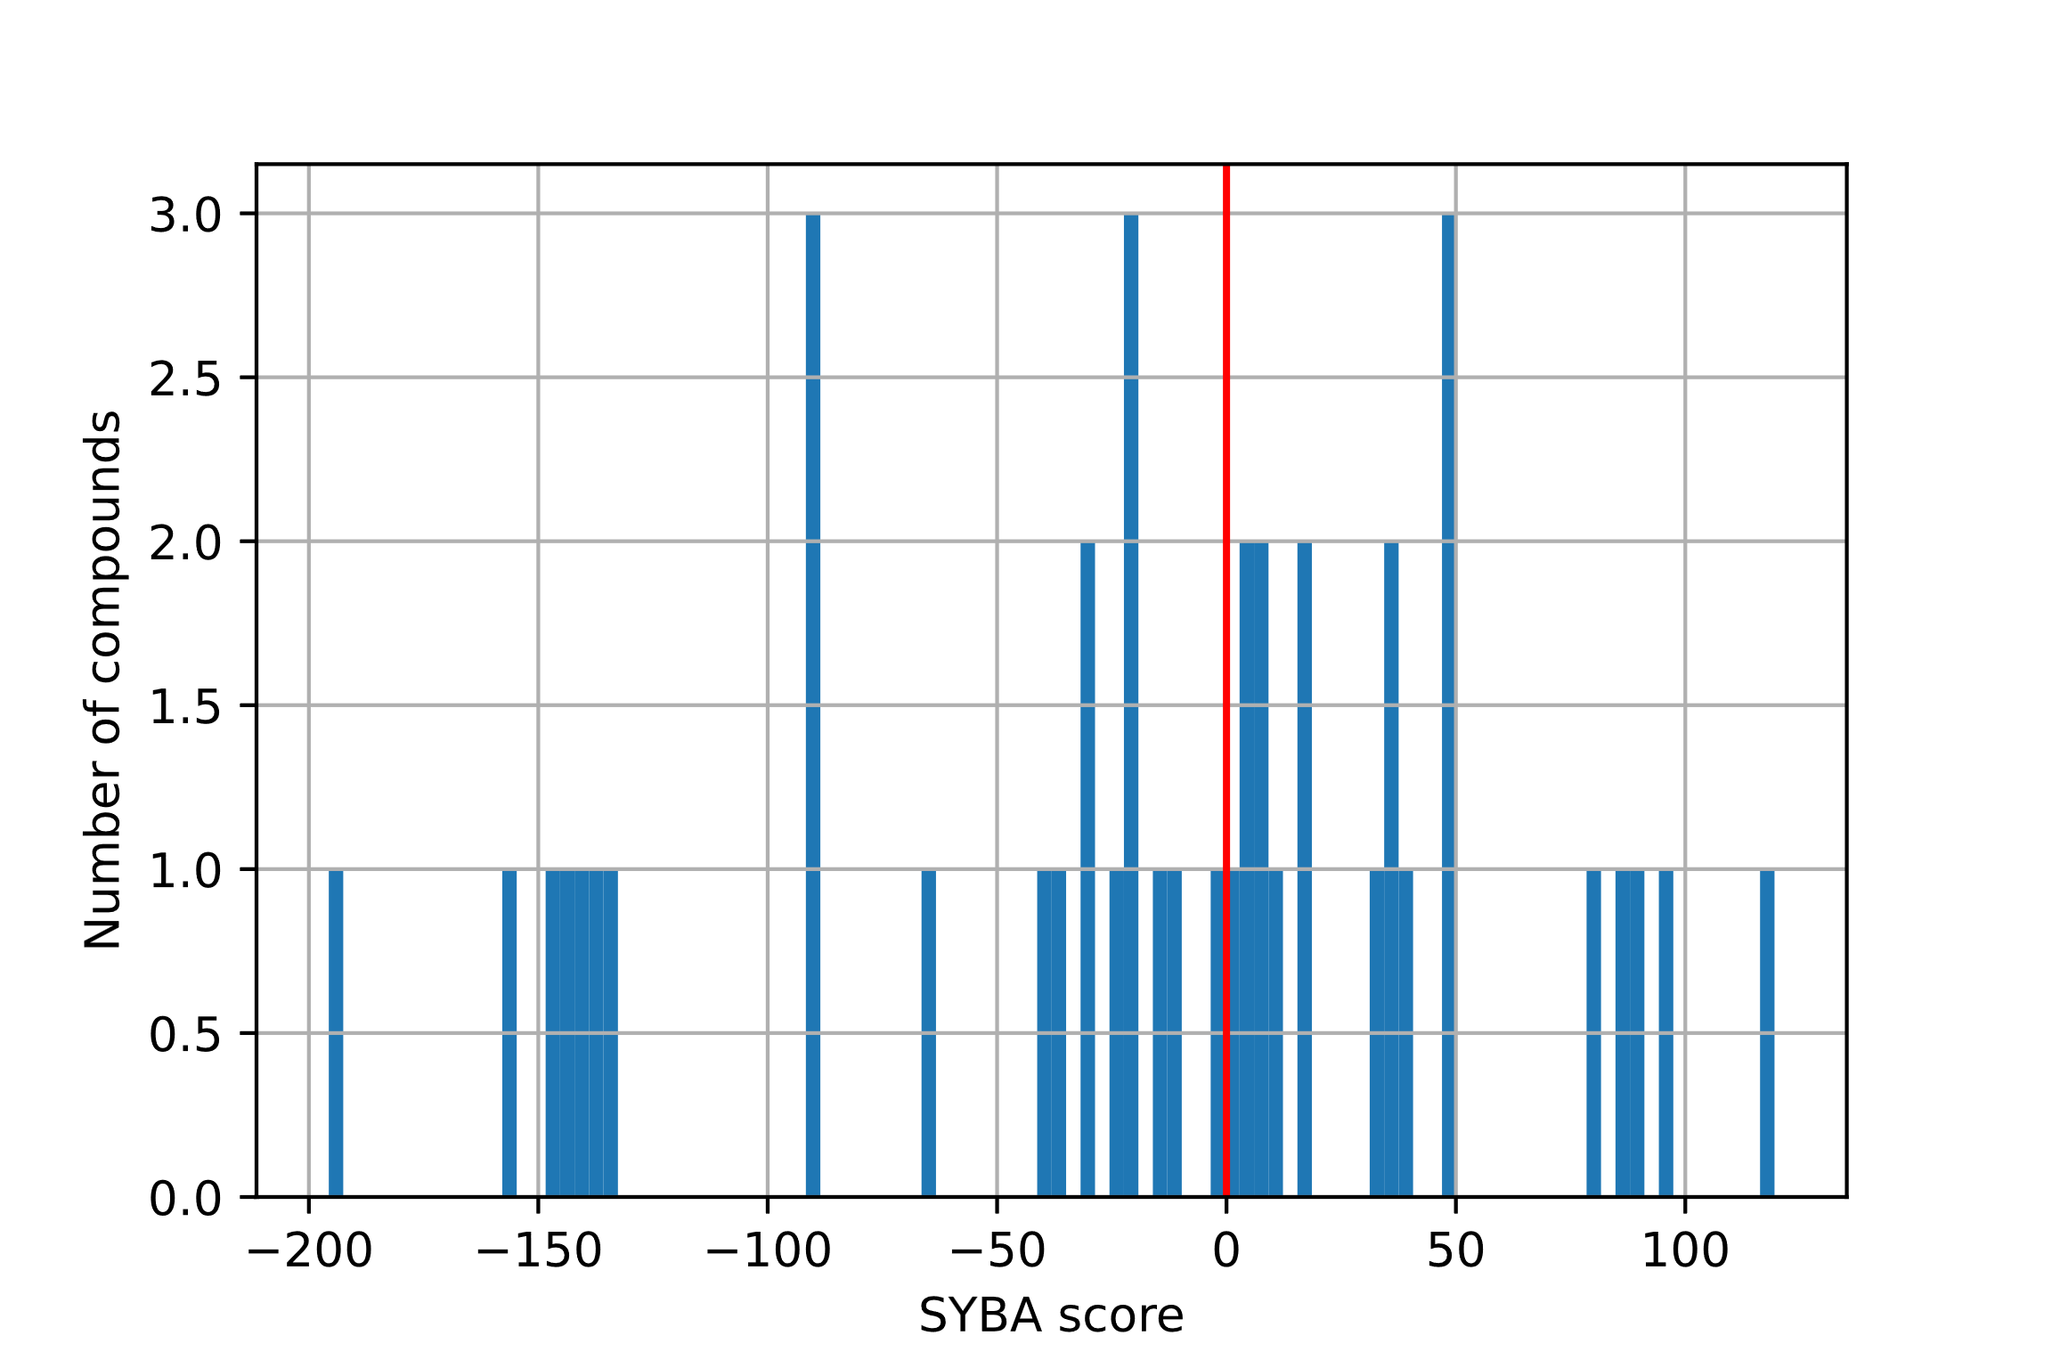

**Figure S18.** The SYBA score distribution over forty-two selected structures   
with a marked threshold (red vertical line).

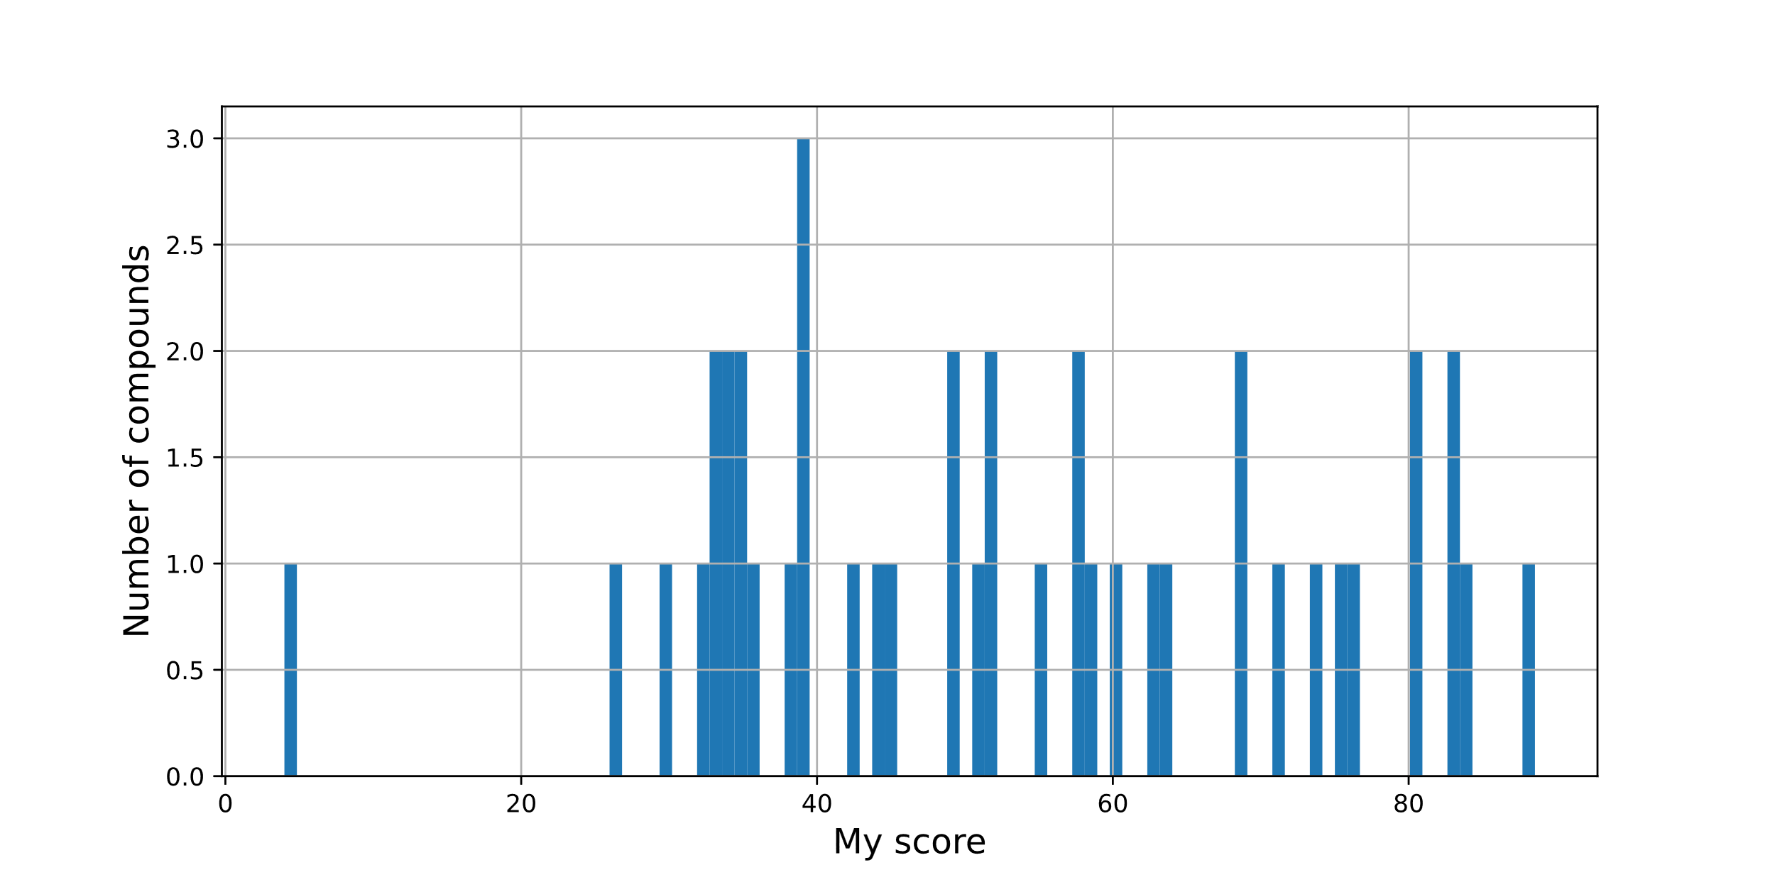

**Figure S19.** My score distribution for **File S29**. – all generated SMILES (forty-two structures).

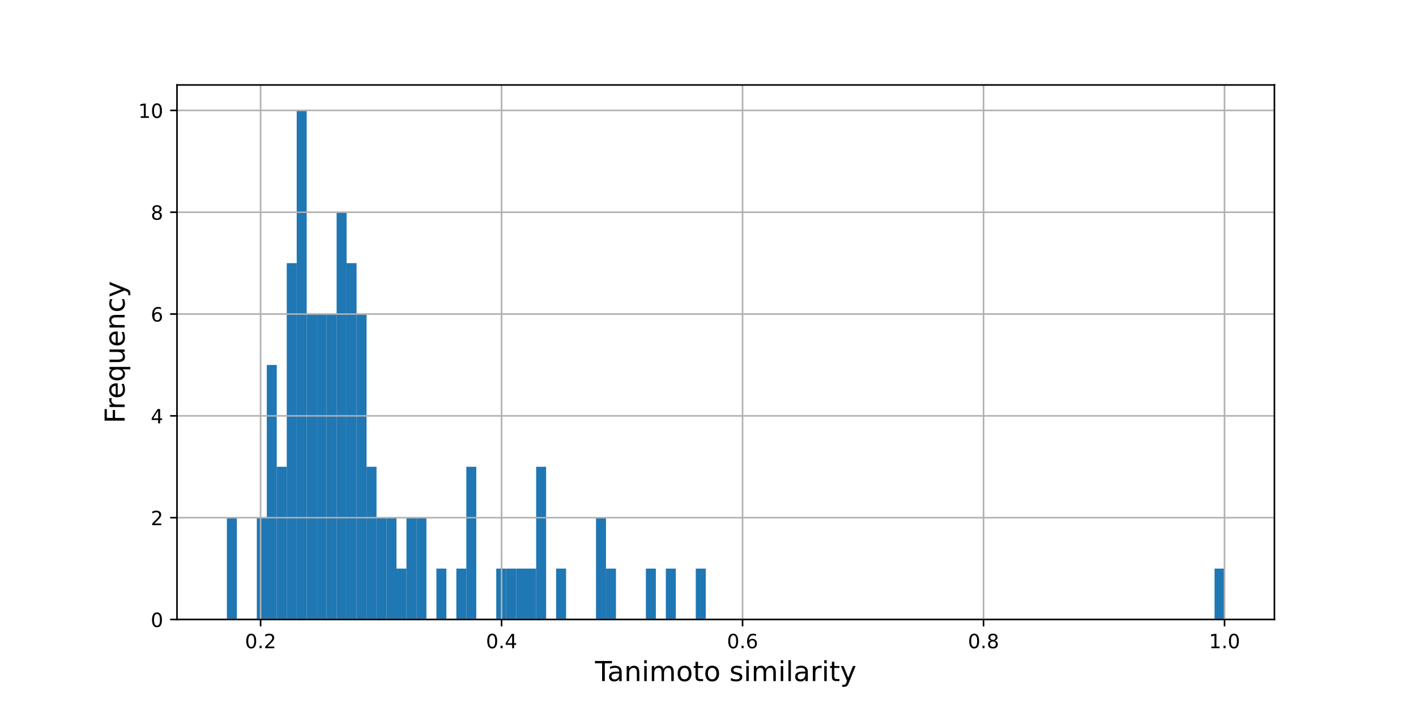

**Figure S20.** The Tanimoto similarity distribution along with twenty   
generated structures after selection (see **Table 1.**) and five initials.

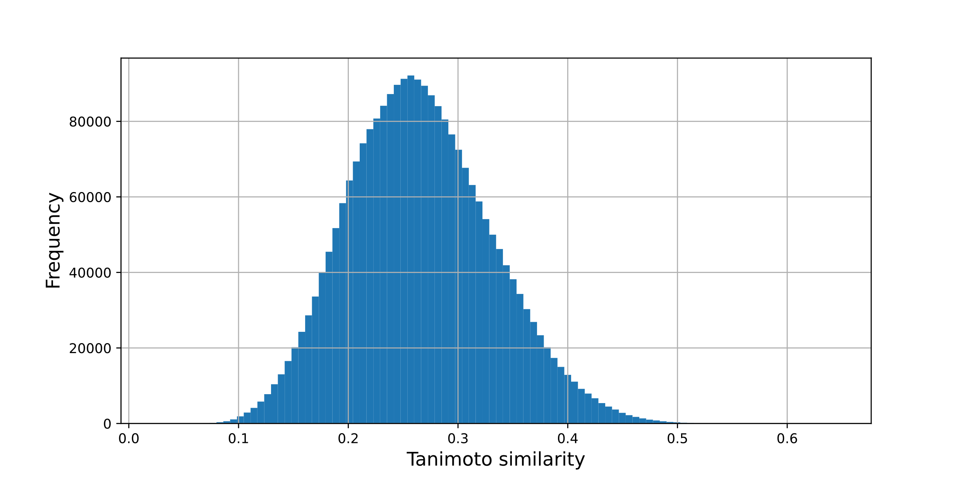

**Figure S21.** The Tanimoto similarity distribution histogram  
between “to be docked” molecules and the training data.

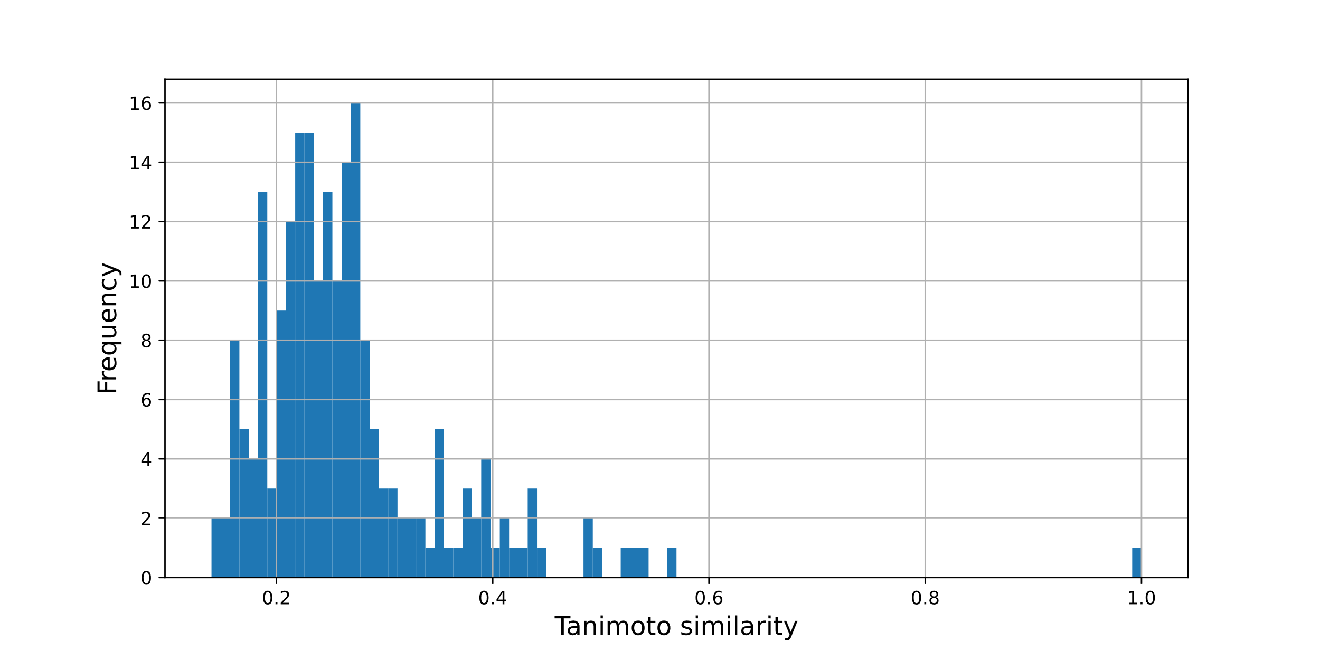

**Figure S22.** The Tanimoto similarity distribution between data after   
QED, Lipinski’s rule of five selections, and initials.

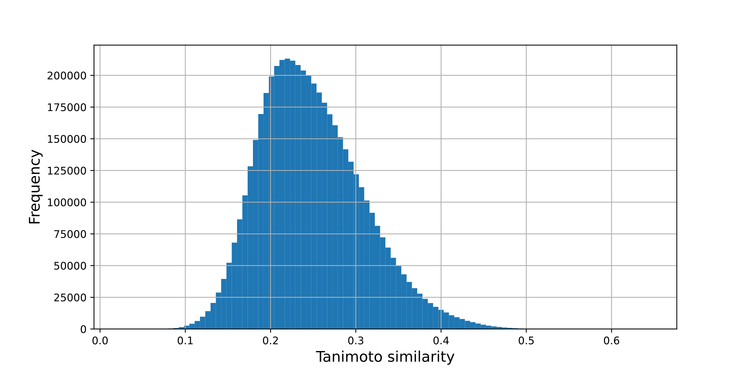

**Figure S23.** The Tanimoto similarity distribution histogram   
between forty-two structures and training data.